**Sadiq Tijjani Umar**

**119200113**

**Biomimicry Project Report**

**The Spider And Its Web: An Approach For Biomimicry Design**

**1)_Discover**

The Spider is part of the class Arachnida from the phylum Arthropoda, it is characterised by it’s having eight legs , chelicerae with fangs generally able to inject venom, and spinnerets that extrude silk. They are the largest order of arachnids and rank seventh in total species diversity among all orders of organisms. Unlike insects, spiders have no antennae, they also have no extensor muscles in their limbs and instead extend them by hydraulic pressure. Their abdomens bear appendages that have been modified into spinnerets that extrude silk from up to six types of glands. Spider webs vary widely in size, shape and the amount of sticky thread used. Spiders have primarily four pairs of eyes on the top-front area of the cephalothorax, arranged in patterns that vary from one family to another.The principal pair at the front are of the type called pigment-cup ocelli ("little eyes"), which in most arthropods are only capable of detecting the direction from which light is coming, using the shadow cast by the walls of the cup. However, in spiders these eyes are capable of forming images. The other pairs, called secondary eyes, are thought to be derived from the compound eyes of the ancestral chelicerates, but no longer have the separate facets typical of compound eyes. Each of the eight legs of a spider consists of seven distinct parts. The part closest to and attaching the leg to the cephalothorax is the coxa; the next segment is the short trochanter that works as a hinge for the following long segment, the femur; next is the spider's knee, the patella, which acts as the hinge for the tibia; the metatarsus is next, and it connects the tibia to the tarsus (which may be thought of as a foot of sorts); the tarsus ends in a claw made up of either two or three points, depending on the family to which the spider belongs. Spiders also have fangs, and the great majority of spiders can use them to inject venom into prey from venom glands in the roots of the chelicerae. Spiders occur in a large range of sizes. The smallest, *Patu digua* from Colombia, are less than 0.37 mm (0.015 in) in body length. The largest and heaviest spiders occur among tarantulas, which can have body lengths up to 90 mm.

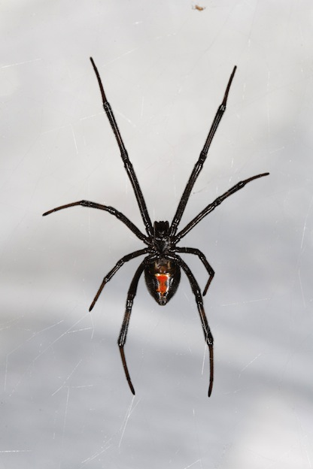 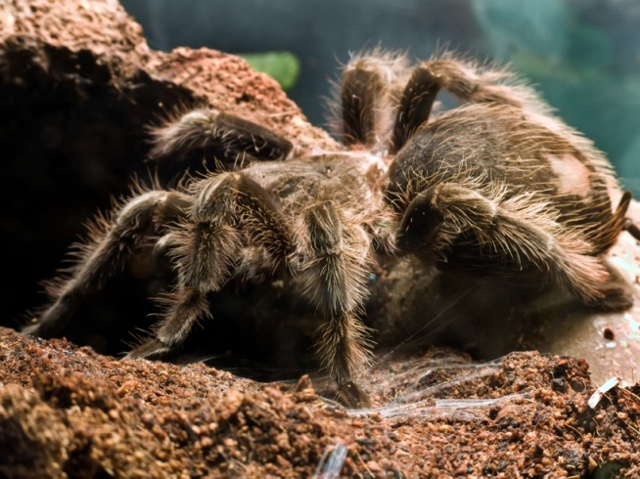

**The Goliath Bird Eating Spider**

**The Black Widow Spider**

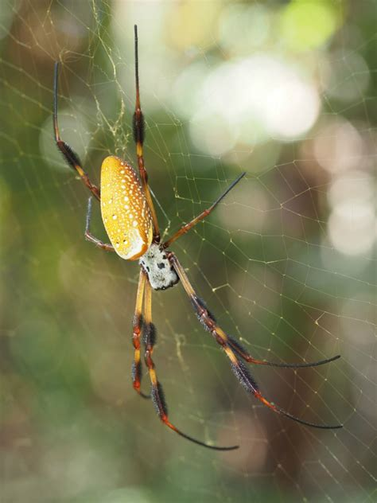

**The Banana Spider**

**2)Abstract**

The spider has shown itself to be very flexible and easily adapts to the environment around it, so much so that it is found on every continent except Antarctica , it has become established in every habitat with the exception of air and water habitats. We will now explore as to how it was able to achieve this.

Feeding Behaviour: Although they are spiders who are non-predatory(for example, the jumping spider) and feed on plants and plant nectar, majority of spiders are predatory, different spiders have different approaches to hunting prey, for example the water spider builds underwater webs that they fill with air and use for digesting prey. The Net casting spiders make small webs and manipulate them to trap prey, Tarantulas and trapdoor spiders ambush their predators by waiting in burrows and coming out for the kill when they sense movement at the periphery.

Defence Mechanisms: The Spider has developed an array of defence mechanisms to maintain itself, many spider species are colour co-ordinated with their habitats so as to protect them from predatory birds and insects, most spiders are insufficiently dangerous or unpleasant-tasting for warning coloration to offer much benefit. Some species of spider have adapted reactive strategies inside of proactive ones, for example the funnel web spider has fangs and strong jaws(some species are extremely venomous) that it will use in a display when threatened, the tarantula has fine hairs on it’s abdomen and legs that it kicks up at an attacker when it is threatened, these fine hairs cause intense respiratory irritation when inhaled by the attacker.

Reproductive Systems: Reproduction in the spider species does not involve the insemination of the female directly, male spiders do not produce ready-made spermatophores (packages of sperm), but spin small sperm webs onto which they ejaculate and then transfer the sperm to special syringe-styled structures, palpal bulbs or palpal organs, borne on the tips of the pedipalps of mature males. Spiders generally use elaborate courtship rituals to prevent the large females from eating the small males before fertilization, except where the male is so much smaller that he is not worth eating.

Web making: Spiders make an array of designs when it comes to webs, but on the whole they fall on one of two categories: Orb webs and Cob webs. Orb webs have hubs where the spiders lurk, usually above the center, if there is an obvious direction in which the spider can retreat to avoid its own predators, the hub is usually offset towards that direction. Cob webs are comingled and three dimensional , they take much longer to make than Orb webs.

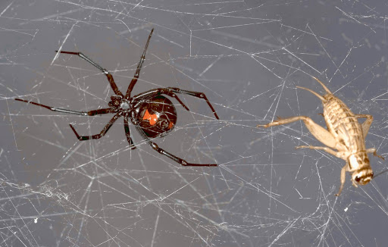

**A Cricket caught in the web of a black widow spider**

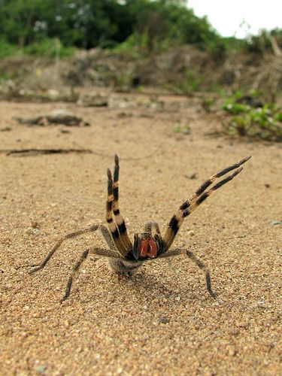

**The Brazilian wondering spider in a threat display**

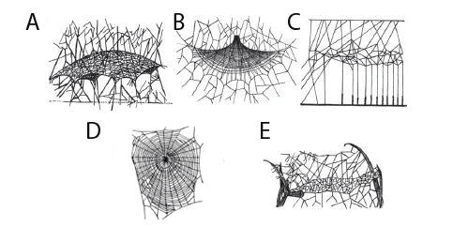

**A-Sheet web. B-Cob web. C-Tangle web. D-Orb web. E-Tubular Web.**

**3)Brainstorm**

The spider has given us insight into various design techniques which we can apply in biomimicry design, most especially in the design of it’s webs. Not only that, but the material used in the making of these webs also provides an interesting area of research , the spider builds it web such that it is elastic and tactile while at the same time the silk used in making the web is firm and resistant to wear and tear.

The design of the Tangle cob web presents an interesting on idea that can be applied in the arrangement of computers in a network. If we consider each point where the silk intersects with another string of silk a grid, then a decentralized grid-like network of nodes emerges. Decentralization of computer networks is a huge advantage in reducing the amount of spread in the case of a computer virus , if a system is centralized when a virus breaks , if one computer receives this virus, then all computers will eventually get infected. The design of the orb web presents an opportunity to make clothing less resistant to wear and tear also.